43.70: a)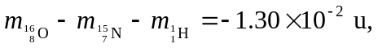 so the proton separation energy is
so the neutron separation energy is 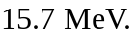 c) It takes less energy to remove a proton.

